Good News For Today Children's Lessons
1

YOU ARE LOVED

Always Say A Prayer Before Studying A Lesson You might just bow your head and say: "Dear God, please help me to understand this lesson. In Jesus' name, I pray. Amen."

H
ave you ever wondered what God is like? Who He is? What He does? Where He lives? Why we should worship Him? There are so many different "things"
that people worship, or call "god" - animals, birds, insects, snakes and idols made of wood or stone. But is there a true God?

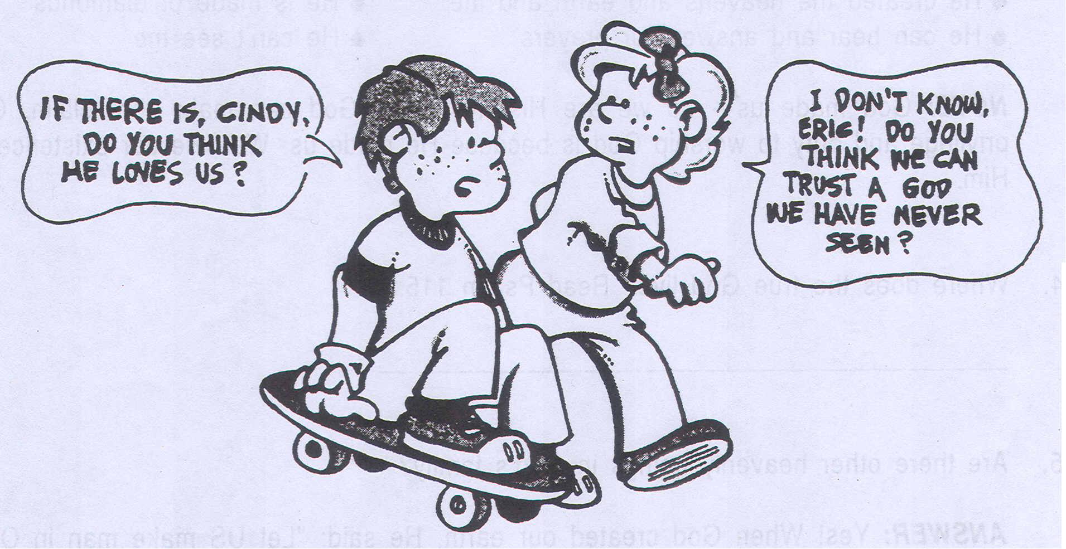

We need to know. We can know!

You are Loved 1

WHAT DOES THE BIBLE SAY?

1. How many true Gods are there? Read 1 Corinthians 8:4-6, then fill in the blanks below.

“... we know that an idol is nothing at all in the world and that there is no God but , … yet for us there is but .”

2. Who is the true God? Read Jeremiah 10:10

- The is the true God

- He is the God

- The eternal .

3. How is the true God different from all other gods that people worship? Read Isaiah 45:12, 18. Click the checkboxes next to the correct answers below.

He created the heavens and earth and me
He is made of diamonds
He can hear and answer our prayers
He can't see me

NOTE: God made us - so we are His! No other God can make that claim. Our
privilege and duty to worship God is because He made us. We owe our existence to Him.

4. Where does the true God live? Read Psalm 115:3 .

5. Are there other heavenly beings in God's family?

ANSWER: Yes! When God created our earth, He said: "Let US make man in OUR image." Genesis 1:26
His Son helped create the universe. Hebrews 1:1, 2
The Spirit of God helped create the earth. Genesis 1:2

2 You are Loved

NOTE: It may help you to understand this family of God if you think of "God" as
their family name. Your family name may be Smith, or Jones, or Gray. But you
also have a first name like Mindy, Billy or John. In God's family there is God
the Father, God the Son (Jesus), and God the Holy Spirit.

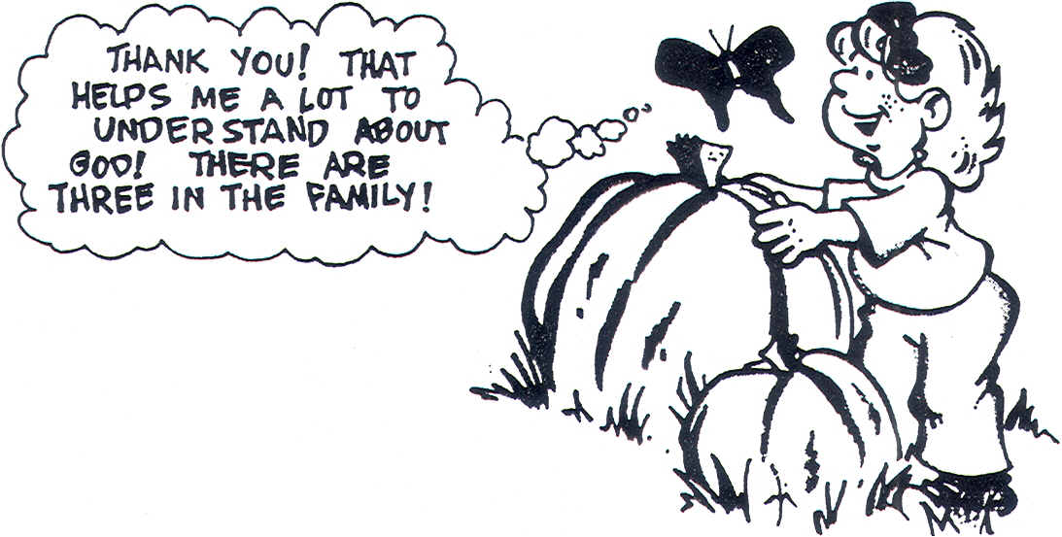
That's right! This is why Jesus told the disciples to baptize everyone in the name of the Father, and the Son, and of the Holy Spirit. Matthew 28:19.

6. How long has God lived? Read Psalm 90:2, then fill in the blanks.

"...From to . "

NOTE: That's a long time, isn't it? No one can even imagine how long that is. God has always been alive, and He will always be alive! That is a little hard for us to understand because everything we know has a beginning and an ending, doesn't it? But God has existed forever.

7. What is God really like? Read Psalm 147:3-9, then fill in the blanks with some of the things God does.

- He heals the . • He calls the stars by .

- He is mighty in . • He provides for the

beasts and birds.

8. What does God tell us to do when we have problems? Read Psalm 50:15, then fill in the blanks.

" upon me...I will .

You are Loved 3

- But the most wonderful characteristic about God is in the coded message Jesus sends you. Break the code and fill in the letters below to find this secret message for you.

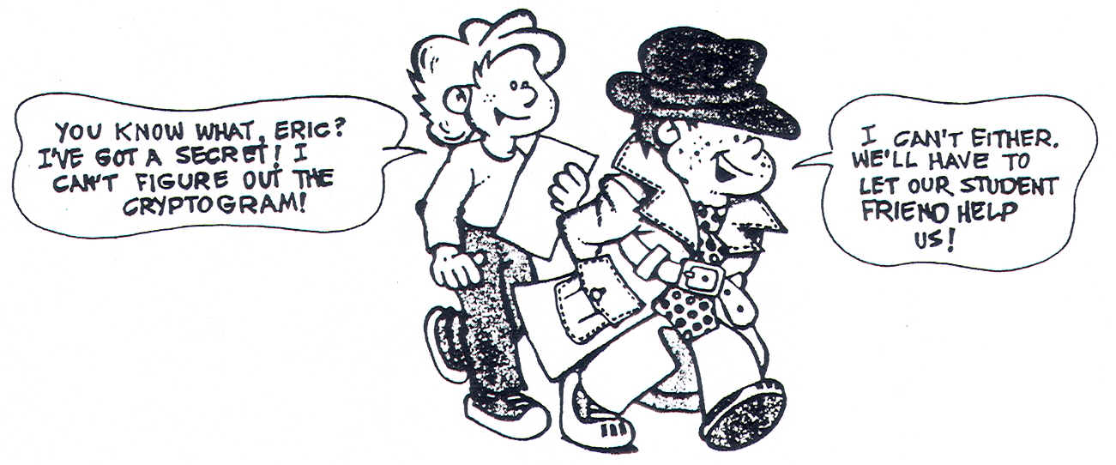
CRYPTOGRAM CODE:

A E F H I L M O R S T U V Y



4 You are Loved

NOTE: Does it surprise you that the great God who created us and the world loves you? It shouldn't. The Bible says that nothing can separate us from His love - ever! (Romans 8:38-39)

God loves you when you are lovable and when you are unlovable. It doesn't make any difference to Him if you are black or white, red or brown, beautiful or ugly! He loves you just the same. And He loves you forever!

10. What does God say He will never do?

ANSWER: God says that even mothers sometimes forget their children, but He says, "Though she may forget, I will not forget you! See, I have engraved you on the palms of My hands." (Isaiah 49:15, 16)

God demonstrated His love by giving His Son to die for you. He loves you very much. "He's big enough to rule the mighty universe, yet small enough to live within your heart."

THINK IT THROUGH

After studying this lesson, click the checkbox next to the answer below which best describes your love for God.

A little bit

A lot

A whole lot

ACTIVITY

Click the checkbox next to the correct statement about idols:

Click the checkbox next to the correct statement about God:

Can't see

Created you
Forgives your sins
Loves you
Can't talk or hear
Worthless

Loves you forever
Can't help you
Answers your prayers
Feeds the animals
Can forgive your sins
Created you

11. What did you learn in this lesson that helps you to understand and love God more?

YOUR RESPONSE:

NOTE: For additional information on this subject read The Bible Story, Volume 7, pp. 160-163; Volume 10, pp. 161-164
5 You are Loved

Type the names of five (or more) people that you love and say how YOU show them YOUR love.

NAME | BECAUSE I LOVE THEM I . . . .
1.
2.
3.
4.
5.
6.
7.
8.



6 You are Loved

God loves you and He says "I am with you always." We can always talk to God - not only when we kneel by our bed at night - but at any time.

Look at each of the situations below. Have you ever found yourself in a similar situation? Think of something you could silently pray if that were happening to you, and type your prayer in the black spaces in the little cloud.

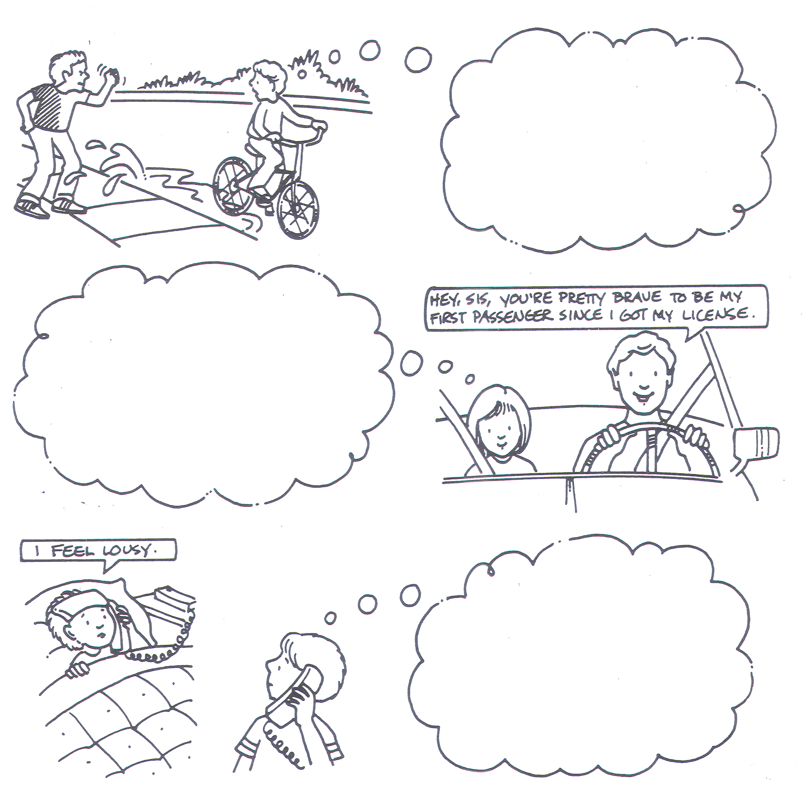
7 You are Loved

